Antonio Petrazzuolo, Ethan Resnik, Ifrah Malik, Jack McGinley, Yashika Y

Professor Michels

Professor DeGood

MGT385/CSC315

17 February-02 May 2023

Phase 2: Are Greenhouse Gas Emissions lowered with electric vehicle use?

Our group has collected data relevant to the questions we are attempting to answer using our database. We have gathered Electric Vehicle Ownership Data, Vehicle Miles Traveled Data, Community Profile Data, Community-Scale GHG Emissions Data, Walk Scores for NJ Cities Data, and Data on EV Charging Stations in NJ for incorporation into our database. The previously listed datasets will provide our team insight into the population densities, median household income, and GHG emissions from passenger vehicles from each municipality, as well as the percentage of EV ownership and locations of EV charging stations across NJ.

With the data that was collected, these are the following questions we are trying to answer. The most important question is: “Do electric vehicles lower greenhouse gas emissions in each municipality?” Considering the economic background of each municipality, analyzing the electric vehicle usage can give a team an idea of how different a municipality with heavy use of gas vehicles looks compared to one that relies on electric vehicles. In congruence with the previous question, is there a correlation between walk scores and greenhouse gas emissions based on population density?

“Are there municipalities eligible for certain sustainability programs or rewards based on their current practices?” Determining this can benefit a municipality because it can give a municipality an incentive to go green by earning these certain rewards.”Are there areas where certain municipalities can improve their sustainability practices?” With this question being solved, municipalities can get an idea of where they can improve environmentally; therefore, giving that said municipality a slight incentive.

The data we found on the Sustainable Jersey page helps us explore these questions. The data we collected can help municipalities identify certain sustainable Jersey actions that could be beneficial to them. We wanted to focus mainly on the transportation aspect and the data we obtained showcases that. The GreenHouse Gas emissions by Vehicle data found on the NJ sustainability site showcases the impact of GHG emissions by different vehicle types in different municipalities in New Jersey. Correlating this data with the Electric Vehicle ownership data, we can identify how many people own Electric vehicles in specific municipalities and if electric vehicles impact greenhouse gas emissions. We can also identify whether or not Electric Vehicles are viable alternatives to passenger vehicles for a given municipality. Looking at the Community Profile data, focusing mainly on the transportation factor, we also want to compare If municipalities with lower walkability scores result in higher GHG emissions, and if that's true then it's better to promote EVs and more charging stations in those certain areas with higher GHG emissions.

The incentive program can provide a solution to encourage municipalities to use electric vehicles over conventional gas-powered vehicles. “The New Jersey Board of Public Utilities (NJBPU) is providing funds to state and local government authorities in New Jersey to help them purchase electric cars (EVs) and Level 2 vehicle charging stations. Applicants may be awarded incentives for up to ten vehicles and four Level 2 charging stations, depending on the size of the company“ (“NJBPU Clean Fleet Electric Vehicle Incentive Program”, n.d.). It is highly likely that data shows that municipalities with incentives have lower emissions which has a positive impact on the environment which means more incentives should be implemented in order to encourage behaviors that help the environment.

The greenhouse effect describes how "greenhouse gasses" trap heat at the Earth's surface. These heat-trapping gasses act like a blanket wrapped around Earth, keeping it warmer than it would be without them. Carbon dioxide, methane, nitrous oxides, and water vapor are examples of greenhouse gasses. Scientists have discovered that the warming effect of carbon dioxide aids in the stabilization of the Earth's atmosphere. The terrestrial greenhouse effect would collapse if carbon dioxide were removed. Without CO2, the Earth's surface would be 33°C (59°F) colder. However, for the last century or two, people have been meddling with the planet's energy balance, primarily through the use of fossil fuels, which emit carbon dioxide into the atmosphere. Carbon dioxide levels in the atmosphere have been steadily growing for decades, trapping extra heat at the Earth's surface, and driving temperatures to climb (Chandler, 2023).

Global warming has many negative impacts on our environment including stronger hurricanes, desertification, decreases in snow covers and ice, and rising sea levels. (“Infographic - the Effects of Global Warming,” n.d.). Our personal vehicles are a major contributor to GHG. Collectively, cars and trucks account for nearly one-fifth of all US emissions, emitting around 24 pounds of carbon dioxide and other global-warming glasses for every gallon of gas. The use of electric vehicles eliminates these extra emissions and helps slow the cycle of climate change (“Car Emissions and Global Warming, 2014”).

There are many key ethical and environmental issues that are attached to global warming and climate change. The ethical principles of climate change revolve around the moral obligation to protect the environment for future generations, to fairly distribute the costs and benefits of climate change, to take action to prevent harm even when the science is uncertain, and to recognize the common but differentiated responsibilities of all countries to act, with developed countries having a greater responsibility to act as a result of their large amount of emissions. These principles underline the significance of taking action to reduce climate change and ensure that its repercussions are fairly distributed (The Ethical Principles of Climate Change, 2022). Global warming has a profound impact on human health, generating temperature increases and extreme weather events that increase the incidence and spread of many diseases. Some of the direct effects of global warming on health include heat-related sickness and death, with vulnerable people being especially vulnerable. Furthermore, changes in temperature and precipitation patterns cause changes in the prevalence of infectious diseases. Climate change exacerbates air pollution, leading to respiratory and cardiovascular disorders. Natural catastrophes are becoming more common and severe as a result of global warming, causing injury, displacement, and mental health issues. These health effects of global warming can be reduced by limiting climate change and implementing adaptation measures (Climate Effects on Health, 2022).

Use Case: View Electric Vehicle Information

Primary Actor: User

Description: The user views the specified information about Electric vehicles

Scenario:

1. System will prompt user to select county in NJ
2. User makes selection
3. User will select information about Electric vehicles
4. User will refine selection of electric vehicle information
5. User will make selection of electric vehicle information they wish to view
6. Information will be displayed to user

Use Case: View Database Municipalities

Primary actor: User

Description: The User will view a table of the database

Scenario:

1. User is prompted to select a county in NJ
2. User makes the selection
3. User is prompted to select a municipality within selected county
4. User makes the selection
5. User is prompted to select the data they would like to view
6. User makes the selection and is directed to the data

Phase 3: The Database Model Explained

A relational database is a type of database that stores and provides access to data points that are related to one another. Relational databases are used on the relational model, an intuitive, straightforward way of representing data in tables.

Data is arranged into tables with rows and columns in relational databases, and the relationships between the tables are defined by unique keys. Users can insert, update, and delete data using SQL (Structured Query Language), which is used to manage and change the data kept in these tables. Regardless of the particular database management system used, this standard language offers a consistent way to interface with the database. (“What is a relational database?”, n.d.).

The capacity of relational databases to guarantee data security and integrity is one of their main advantages. This is done by enforcing the data type, field length, and referential integrity through the application of constraints and rules established in the database structure. This ensures that data is input accurately and consistently, helping to prevent errors and discrepancies. (“What is a relational database?”, n.d.).

“ACID stands for Atomicity, Consistency, Isolation, and Durability, all of which refer to important properties of a transaction, a term used to describe a unit of database work. Relational databases thrived on workloads that required ACID, just as some non-relational systems do today” (“What is a Relational Database?”, 2019).

The fundamental advantage of the relational database architecture is that it allows for an intuitive representation of data and quick access to linked data points. As a result, relational databases are most typically employed by enterprises that require the management of vast amounts of structured data, such as inventory monitoring, transactional data processing, and application logging. (“What is a relational database?”, n.d.).

In a variety of settings, including financial systems, e-commerce websites, scientific research, and healthcare, relational databases are very adaptable and useful. They offer a high degree of flexibility in terms of how data may be assessed and analyzed while also enabling the efficient, strong retrieval of enormous volumes of data. In conclusion, relational databases are a useful tool for managing and analyzing data and provide a dependable and safe method for storing, organizing, and manipulating massive volumes of data (“What is a Relational Database, 2019).

Our ER diagram models our electric vehicles' impact on the greenhouse gas emissions database. The model contains four entities and three relationships between the entities. The four entities are greenhouse gasses, electric vehicles, fuel vehicles, and community profile. There is an ownership relationship between the electric vehicles entity and the community profile entity, an emissions relationship between the greenhouse gas and fuel vehicles entity, and a producer relationship between the greenhouse gas and community profile entity. Each entity has its own attributes that are used to describe the entity. Each entity has a composite primary key composed of the municipalities, county, and year attributes used to uniquely identify each relation.

The attributes of the community profile entity describe the size and population characteristics of each municipality and have a relationship with the greenhouse gas entity, which contains attributes that describe the total emissions from each municipality. The electric vehicles entity has attributes that reveal the ownership and number of electric vehicles in each municipality. The fuel vehicles entity has attributes that show the miles traveled, used for transportation, and emissions from fuel vehicles in each municipality. The relationships between each entity reveal how fuel vehicles contribute to greenhouse gas emissions and the impact that electric vehicles can have on reducing the emissions of greenhouse gasses. It also reveals the ownership of electric vehicles and the emissions produced in each municipality based on the population characteristics of each municipality.

Given the design of the database model, the goal is to differentiate the use of greenhouse gas emissions from electric vehicles and fuel vehicles. Looking at the greenhouse gas emissions table of data, we see the elements shown by our model. Which include the county, municipality, type of passenger vehicle emissions, metric tons of Carbon dioxide equivalent, and the year. In each of these categories, we are looking to see if greenhouse gas emissions are lowered through the use of electric vehicles. Our model shows a relationship between the variables n and m which is the relationship between greenhouse gas emissions and fuel vehicles. There is also a relationship between 1 and N– which shows the relationship between Community profile and greenhouse gasses. This shows how certain parameters of a community like population, median household income, population, and percent of people in poverty relate to the number of greenhouse gasses emitted by different communities. 1 to N also shows the relationship between community profile and electric vehicle use.

There is an assumption that each community/municipality is unique and can have many eclectic vehicles. This relation also shows how population characteristics impact the ownership of electric vehicles. This model will help us answer the question: “Do electric vehicles lower greenhouse gas emissions in each municipality?” The relationships illustrated can help us find specific data that will help answer this question and achieve our goal of finding the impact of electric vehicles on fuel vehicles and different municipalities.

Use Case: Locate Information

Primary Actor: User

Description: The user locates information present in the database

Scenario:

1. User will navigate to the database webpage
2. System will prompt user to search begin search
3. User will presented with names of municipalities
4. User will select one or more municipalities they wish to view the data of
5. User will be presented with data grouped by specific municipality
6. User can further narrow search by selecting data of entity

Use Case: Select

Primary Actor: User

Description: The user selects information they wish to view

Scenario:

System will present user with data of entities

User will be given option to select data from specific entity

Users will further refine selection of data (ex. Filter by EV ownership, total GHG emissions, etc.)

User will select multiple columns of data from each entity data table

User will be shown specified or filtered selection of data from tables

User can compare columns of data selected

Use Case: View

Primary Actor: User

Description: The user views the information they have selected

Scenario:

1. System will present the user with selected data
2. User can select entries they wish to view
3. User can view specific ownership of EVs in each municipality
4. User can view total emissions produced by passenger vehicles in selected municipality
5. User can compare EV ownership and total passenger vehicle emissions by municipality
6. User will be presented with the data they have selected

ER/EER Diagram: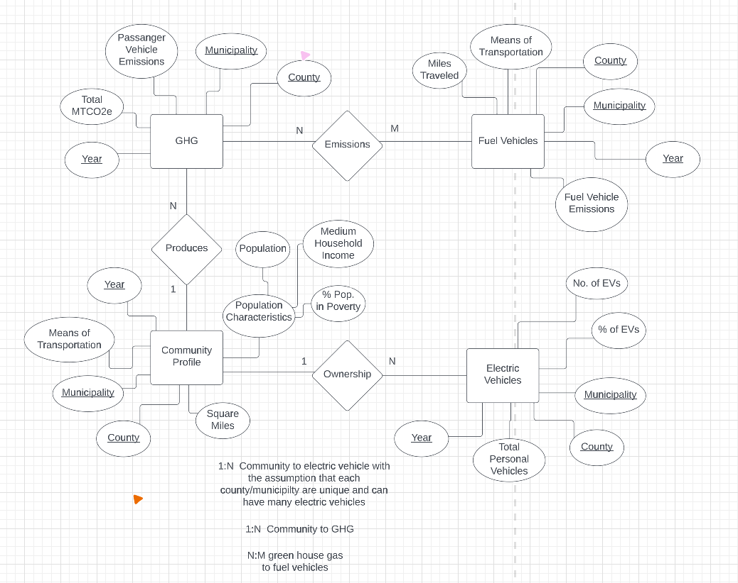

Updated schema: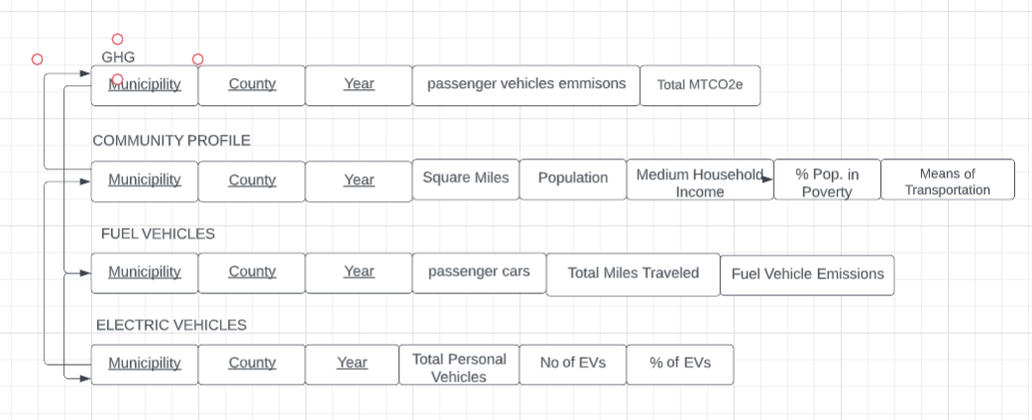

UML Use Case Diagram: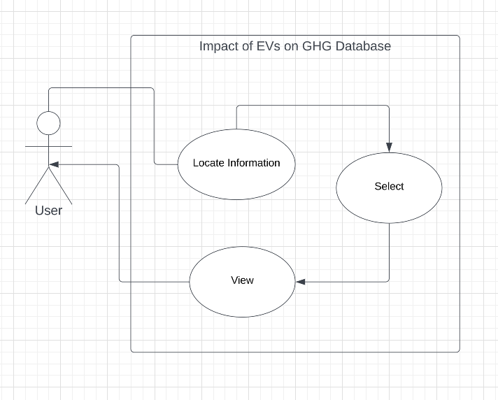

Phase 4: Database Ethical Implications

Our proposal involves giving municipalities incentives to switch to electric vehicles. Municipalities can take a number of actions to promote sustainable mobility and encourage the usage of electric cars (EVs). To encourage consumers to purchase EVs, one strategy we can use is to provide incentives like tax rebates, cash back, and charging stations. Increased EV adoption can also be achieved by working with nearby utilities to build up public charging stations and educating communities about EVs (Anthony Jnr., 2021). In order to reduce pollution and enhance air quality, towns can also switch their fleets of public transit vehicles over to electric buses and other EVs. Municipalities can use renewable energy sources like solar or wind energy to sustainably power EVs. Additionally, they can implement sustainable transportation measures that encourage carpooling, biking, and walking, which could reduce the demand for individual auto ownership and the number of vehicles on the road (Marta. Moses, 2023).

There are many positive impacts on consumers by implementing electric vehicles in municipalities. First of all, there is no need for gasoline, saving citizens money on gas. The cost of $0.10 per kW is the same as paying less than $1 per gallon of gas to drive. Driving electric vehicles saves drivers, on average, $700 in gasoline costs per year. Evs also don't emit pollutants, meaning they are environmentally friendly. More than 177,758,804 kg of CO2 emissions have been cut by electric vehicle drivers. Citizens will also have fewer repairs because of an effective electric motor Consumers save on operating costs since electric motors have fewer parts and cause less damage than conventional, non-electric vehicles (“Advantages of Electric Vehicles”, n.d.).

There are also many ethically positive impacts of Electric vehicles. EVs and charging stations have various positive environmental effects. EVs release fewer greenhouse emissions than conventional gasoline-powered vehicles, which lowers air pollution and improves health. EVs and charging stations enable the integration of renewable energy resources like solar, wind, and hydroelectric power, resulting in a cleaner and more sustainable energy system. Additionally, EVs promote domestic energy independence and reduce reliance on foreign oil, which has ethical and geopolitical repercussions. Moreover, EVs are more accessible to those with disabilities due to their quiet operation and low maintenance needs. Additionally, the use of EVs and charging stations in low-income areas can help to reduce air pollution in regions that are disproportionately affected by it. The switch to EVs may also lead to job growth in the infrastructure operation, installation, and maintenance industries. Last but not least, encouraging greener modes of transportation and cutting carbon emissions empowers customers to make more moral decisions about their purchases, fostering a more sustainable future (EDF, 2023).

Concerns related to electric automobiles' ethical and environmental implications have grown as their popularity has grown. The exploitation of child labor to extract minerals like cobalt needed for their batteries in other nations represents a negative externality. Amnesty International has called attention to the abuse of child labor in the mining sector as a human rights infraction that calls into question the morality of promises made for electric cars. Cobalt manufacturing has increased dramatically as a result of the rising demand for electric vehicles, with many businesses acquiring it from nations with loose labor laws and environmental regulations. Kumi Naidoo, the secretary general of Amnesty International, has urged for the preservation of human rights to take precedence over addressing climate change and issued a warning that barring dramatic changes, human rights violations will continue to contaminate the batteries that power green vehicles. This problem underlines the requirement for more accountability and openness in the supply chain for electric car parts (World Economic Forum, n.d.).

There are more negative ethical implications of electric vehicles. First batteries or electric vehicles can endanger human health. If used batteries can't be properly disposed of it will seriously harm both the environment and people. Damage to the battery will cause a discharge of very toxic gas, produce a lot of heat, and can start fires. Additionally, waste batteries pose a number of risks to people, and high lithium concentrations can seriously harm the endocrine and nervous systems of people (Wan1 & Wang2, 2022). Another concern is that electric vehicles produce fewer greenhouse gasses when they are in use, but the electricity used to charge them may originate from fossil fuel-powered facilities, which still have an adverse effect on the environment. The number varies greatly depending on how local power is produced, such as utilizing coal or natural gas, both of which create carbon pollution, as opposed to renewable alternatives like wind or solar, none of which do (Environmental Protection Agency. 2023).

There are possible solutions for infrastructure problems a municipality might face when having to implement charging stations. Utility upgrades and electricity rates may need to be considered in order to support larger or faster charging installations at a facility. This may involve upgrading specific parts of the local power distribution infrastructure or electrical-service wiring. Prior to applying for permits, utilities and charging station developers should conduct thorough planning and analyses. Factors that need to be considered include anticipated local EV adoption, available capacity on the local electric grid, right-of-way access, easement issues, and other factors that could impact where charging stations are placed. Without concerted communication on the benefits of EVs and increased visibility of EVs on the road, consumers, companies, and public fleets may continue to invest in conventionally powered vehicles ( U.S. Department of Transportation, 2023). The more difficult problems are the issues of the environmental impacts of recycling electric car batteries. The process of recycling car batteries needs to be reviewed in order to reduce the negative environmental implications. Similar to this issue is the problem of the deadly human labor in other countries to manufacture electric car batteries. Perhaps more research needs to be done so we can manufacture batteries in a more ethical way without the cost of human life. The transition to electric vehicles should be done slowly so we can really think about how to bypass these tough ethical issues (U.S. Department of Transportation, 2023).

In municipalities, there will be various stakeholders impacted by a change to electric vehicles. These stakeholders include consumers, the government, car manufacturers/workers, oil and gas companies, and energy companies. Despite ethical concerns that impact these stakeholders, the environment, and people from other countries, we believe the switch to electric vehicles is the future and this change needs to happen in order to save the environment.

The impact of greenhouse gases on the environment is devastating. The relationships between each entity reveal how fuel vehicles contribute to greenhouse gas emissions and the impact that electric vehicles can have on reducing the emissions of greenhouse gasses. These heat-trapping gasses act like a blanket wrapped around Earth, keeping it warmer than it would be without them. Carbon dioxide levels in the atmosphere have been steadily growing for decades, trapping extra heat at the Earth's surface, and driving temperatures to climb (Chandler, 2023).

Global warming has many negative impacts on our environment including stronger hurricanes, desertification, decreases in snow covers and ice, and rising sea levels (“Infographic - the Effects of Global Warming,” n.d.).

Based on our data from our website fuel vehicles entity has attributes that show the miles traveled, means of transportation, and emissions from fuel vehicles in each municipality. The relationships between each entity reveal how fuel vehicles contribute to greenhouse gas emissions and the impact that electric vehicles can have on reducing the emissions of greenhouse gasses. This shows that fuel-based vehicles are contributing to the destruction of our environment. It is important in the future we push for incentives to encourage the swap to electric vehicles in order to save our planet from global warming.

References (Phases 2-4)

Anthony Jnr., B. (2021, May 10). *Integrating Electric Vehicles to achieve sustainable energy as a service business model in Smart Cities*. Frontiers. Retrieved April 29, 2023, from https://www.frontiersin.org/articles/10.3389/frsc.2021.685716/full

“Car Emissions and Global Warming.” *Union of Concerned Scientists*, Union Of Concerned Scientists, 2014, https://www.ucsusa.org/resources/car-emissions-global-warming#:~:text=Our%20 personal%20 vehicles%20are%20a,for%20every%20 gallon%20of%20 gas.

Chandler, David. “Greenhouse Gases.” *MIT Climate Portal*, MIT News, https://climate.mit.edu/explainers/greenhouse-gases#:~:text=The%20 greenhouse%20effect%20is%20not,the%20 greenhouse%20effect%20 changes%20too.

“Climate Effects on Health.” *Centers for Disease Control and Prevention*, Centers for Disease Control and Prevention, 25 Apr. 2022, [https://www.cdc.gov/climateandhealth/effects/default.htm#:~:text=The%20health%20effects%20of%20these,and%20threats%20to%20 mental%20health](https://www.cdc.gov/climateandhealth/effects/default.htm#:~:text=The%20health%20effects%20of%20these,and%20threats%20to%20mental%20health).

“Data Center.” *Data Center - Sustainable Jersey*, <https://www.sustainablejersey.com/resources/data-center/>.

EDF. (2023). *Ev: Advantages*. EDF. Retrieved April 30, 2023, from https://www.edfenergy.com/electric-cars/benefits

Environmental Protection Agency. (2023). *Electric Vehicle Myths*. EPA. Retrieved April 30, 2023, from https://www.epa.gov/greenvehicles/electric-vehicle-myths

Google Cloud. (n.d.). *What is a relational database (RDBMS)? | google cloud*. Google. Retrieved April 27, 2023, from https://cloud.google.com/learn/what-is-a-relational-database

“Infographic - the Effects of Global Warming.” *What's Your Impact*, 8 July 2017, https://whatsyourimpact.org/infographics/global-warming-effects.

*NJBPU Clean Fleet Electric Vehicle Incentive Program*. Single Grant - Sustainable Jersey. (n.d.). Retrieved April 28, 2023, from https://www.sustainablejersey.com/resources/funding-database/single-grant/?tx_sjcert_grants%5Bfilter%5D=%28pid%3A97+AND+type%3Atx_sjcert_domain_model_grant%29&tx_sjcert_grants%5Bgrant%5D=299&tx_sjcert_grants%5Baction%5D=show&tx_sjcert_grants%5Bcontroller%5D=Grant&cHash=5d6f10fc556384f35a6628b5db0320ae

*Relational databases explained - examples, use cases & more. Fauna. (2019). Retrieved March 8, 2023, from https://fauna.com/blog/relational-database*

“The Ethical Principles of Climate Change.” *UNESCO.org*, UNESCO, 2022, https://www.unesco.org/en/articles/ethical-principles-climate-change#:~:text=Climate%20change%20 not%20only%20 threatens,creates%20new%20forms%20 of%20 injustice.

U.S. Department of Transportation. (2023). *Ev challenges and evolving solutions for Rural Communities*. U.S. Department of Transportation. Retrieved April 21, 2023, from https://www.transportation.gov/rural/ev/toolkit/ev-benefits-and-challenges/challenges-and-evolving-solutions

*What is a relational database?* IBM. (n.d.). Retrieved March 8, 2023, from https://www.ibm.com/topics/relational-databases#:~:text=A%20 relational%20database%20 organizes%20data,key%20 or%20a%20 foreign%20key.

*What is a relational database?* Oracle. (n.d.). Retrieved March 8, 2023, from https://www.oracle.com/database/what-is-a-relational-database/